For sending email to a particular mail id.
From whichever mail id, mail needs to be sent, switch on the following option (Use Less secured apps).
https://myaccount.google.com/lesssecureapps

Then install nodemailer as given below
Npm install nodemailer

Type the following code and use it.
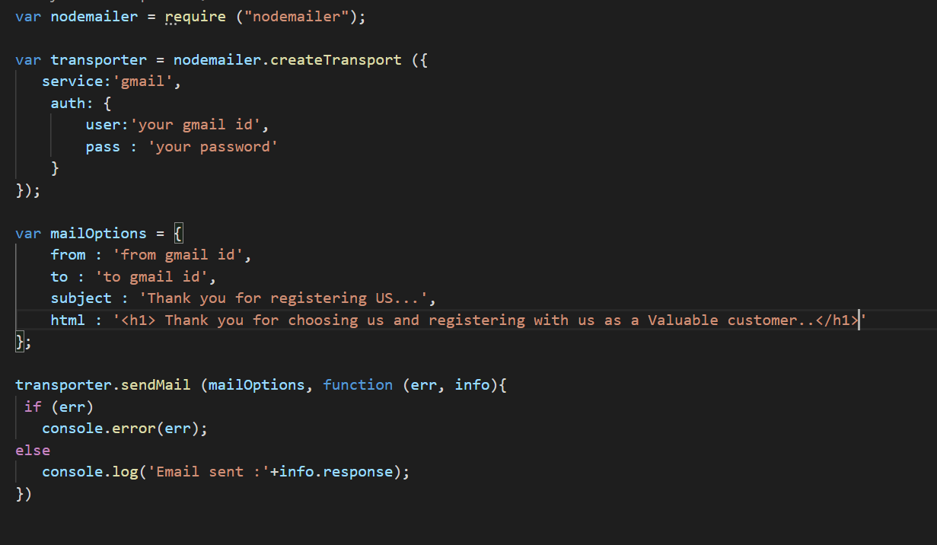

In your application, send an email when the user is registered.
Also send an email to the user when the user purchases any product.

When the user selects forgot password, send the password to the user in the email.

